Hi! Thank you for helping us with this study.
I’ll walk you through what we’ll do on the study day. If anything is hard to understand or you’re not sure about something, just ask me anytime. And if anything feels uncomfortable, you can tell me and we can pause or stop whenever you want.
There will also be breaks during the task, and you can take as much time as you need. At the end of this explanation, we’ll practice together so you can get used to everything and ask any questions you have.
More below!

Why we do this?
We want to learn about how people feel when they look at pictures. Your answers will help us understand that. There are no right or wrong answers. We just want to know how you feel.

What will we ask you to do?
We will show you different pictures and ask you how you feel when you see them. These pictures may show people, places, or other everyday things. Some pictures may feel pleasant, some may feel unpleasant, and some may not make you feel much at all. All these reactions are completely okay. We just want to know how you feel.
After each picture, you will see nine little cartoon figures. Your job is to choose the figure that best matches how you feel and they look like this:

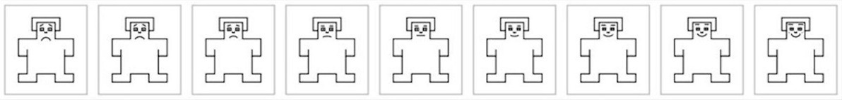
These cartoon figures show how positive or negative something feels.
- The figure on the far left shows a very negative feeling
- The figure on the far right shows a very positive feeling
- The figures in between show feelings that are somewhere in the middle, with the center figure meaning neutral

There are nine buttons with stickers of these figures on them in front of you. You will press the button that shows the figure that is closest to how you feel.
There are no right or wrong answers. Please choose the one that feels right to you.

Two different ways of doing the task
During the study, you will be asked to do one of two things for each picture.
Task 1: Feel your emotions freely
For half of the pictures, we will ask you to just look at the picture and notice how it makes you feel. Do not try to change your feelings. Just let them happen naturally.
Before the picture appears, you will see the words “feel freely” on the screen.
After looking at the picture and freely feel your emotions, choose the small cartoon figure that best shows how you feel.

Task 2: Tone down your feelings
In the other half of the pictures, we will ask you to tone down your emotions. This means that when you look at the picture, you should try to reduce how strong your feelings are and make them feel less intense. In other words, please make your feelings calmer and less strong. There are many ways to do this, and you can choose the way that works best for you. For example, you can think that the picture is staged or not real, or think about something neutral, or remind yourself that it has happened in past, or it is not happening to you.
Before the picture appears, you will see the words “Tone down” on the screen. Please, look at the picture and try to calm your feelings. Then choose the small cartoon figure that best shows how you feel. If you are not able to calm your feelings, that is completely okay. Please choose the figure that shows how you feel in that moment. There is no right or wrong way to do either part.

Now, let’s go through the task step by step…

Step 1: Relax screen
You will see a cross sign (+) on the screen many times during the study, at the beginning and in between all pictures. When this screen appears, just relax and look at the cross sign. You don’t need to do anything during this time. It gives your brain a short break before the next picture. The screen looks like this:
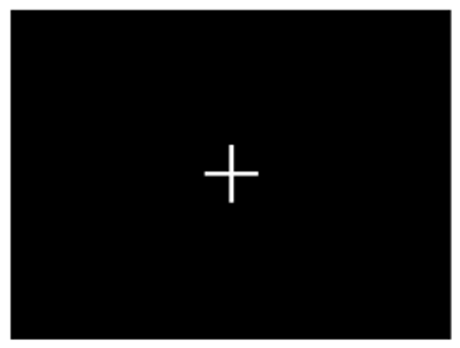

Step 2: Instruction on the screen
Before each picture appears, you will see an instruction on the screen. It will say either “Feel freely” or “Tone down”
- “Feel freely” means you simply look at the picture and experience how it makes you feel.

- “Tone down” means you try to reduce how strong your feelings are.

The screen looks like this:
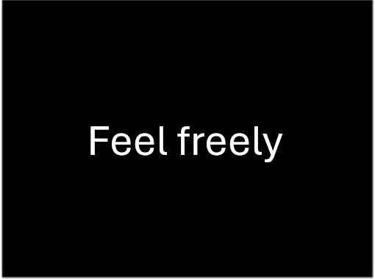 OR 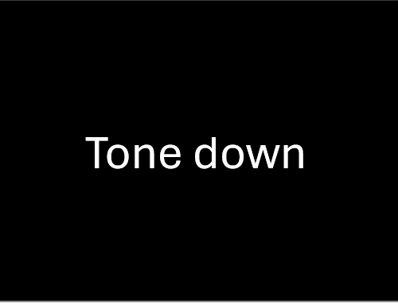

After the instruction, the picture will appear.

Step 3: Picture
Next, you will see a picture on the screen. The picture will appear only for a short time. During this time, you will either feel your emotions freely or try to tone them down, depending on the instructions you received. After that, the figure scale will appear.
The picture could look like this:
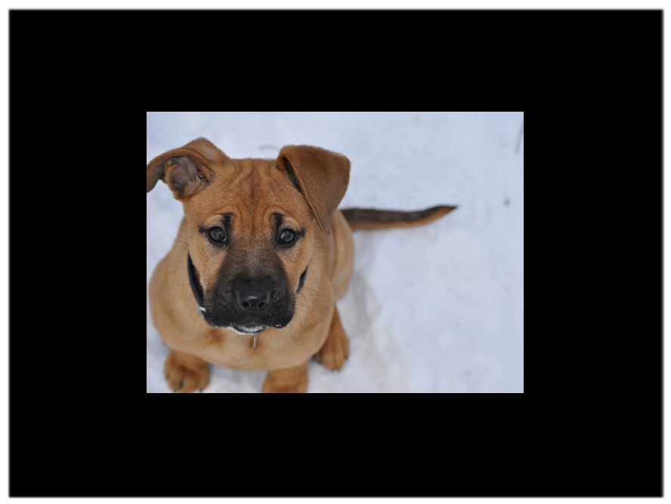

Step 4: Tell us how the picture makes you feel
When you see the five cartoon figures, just tell us how you feel about the picture right at that moment by pressing the button that matches your feeling best.
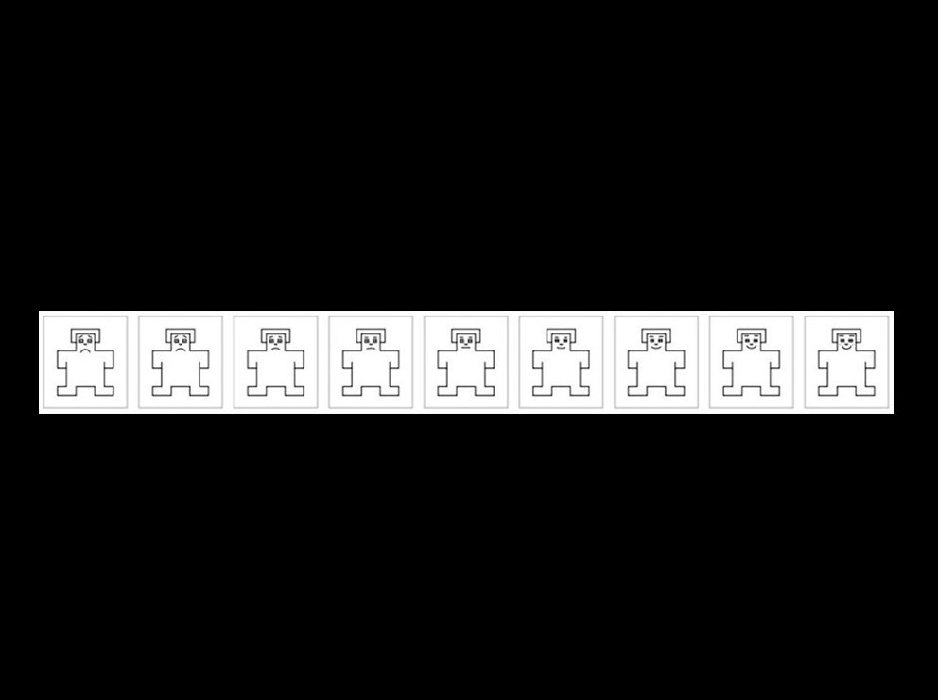

How often will I do this?
You will see a total of 120 images You will see 40 pictures in a block, and we will have four blocks. Each block will last approximately 5 minutes. You will have a break after each block (that is, approximately every 5 minutes). During each break, you can rest for as long as you need. You can press enter to proceed to the next block. In total, you will do this task for around 20 minutes.

Before we start
If you want to stop, take a break, feel tired, or something doesn’t feel right, just let me know at any time. You are completely in control of what happens during the study.
Thanks for helping with this project. Your participation helps us understand how feelings work in the brain, and we really appreciate it.
Thank you!

